Internet of Things Fundamentals

Subject Project
BS AI 6th Semester SP-25 (AIE-3079)
Date: 26-06-2025
Project Title: Smart Environment Monitor: IoT Smoke Detector & Air Index Calculator
Group Name/no.: AI_ZONE / 10

Team Members:
Members | Registration no | Name | Signature
Member-1 (Leader) | 22-NTU-CS-1336 | ABDUL RAFAY
Member-2 | 22-NTU-CS-1355 | M. FAISAL
Member-3 | 22-NTU-CS-1375 | SUFHAN SIDDIQUE
Member-4

Contributions in % of each Team Members for each component
 |  | Member-1 | Member-2 | Member-3 | Member-4
Distribution Components |  | RAFAY | FAISAL | SUFHAN | Name
Coding | ESP32-coding | 40% | 30% | 30%
 | Python Coding | 30% | 40% | 30%
UI Design |  | 30% | 40% | 30%
Database |  | 30% | 40% | 30%
Cloud Integration |  | 40% | 30% | 30%
IoT Gateway |  | 40% | 30% | 30%
Edge Processing |  | 30% | 40% | 30%
Documentation |  | 30% | 30% | 40%
Presentation  Design |  | 30% | 30% | 40%
Replace for other contribution
Replace for other contribution
Replace for other contribution
Replace for other contribution

To be filled by the evaluator

Team-Based Evaluation (60 Marks)
Criteria | Obtained Marks | Out of
System Design & Architecture |  | 10
Hardware Integration & Circuit Setup |  | 10
IoT Gateway and Cloud Communication |  | 10
Working Prototype Demonstration |  | 10
Performance & Reliability Testing |  | 10
Presentation |  | 10
Total (Team-Based) |  | 60

Individual-Based Evaluation (40 Marks per Member)
 | Member 1 | Member 2 | Member 3 | Member 4
Criteria
Understanding of the Project & Role | /10 | /10 | /10 | /10
Code Contribution and Explanation | /10 | /10 | /10 | /10
Q/A VIVA | /10 | /10 | /10 | /10
Documentation/Reporting & Communication | /10 | /10 | /10 | /10
Total (Individual-Based) | /40 | /40 | /40 | /40
Total Overall (60+40) | /100 | /100 | /100 | /100
Weightage Lab Grade (50)

1. Abstract / Executive Summary
This project presents a smart IoT-based Smoke and Air Quality Monitoring System using an ESP32 microcontroller. It integrates a smoke sensor (MQ-2) and an air index sensor (MQ-135) to detect harmful gases and pollution in real time. The system alerts users through LED indicators and sends live data to the Blynk Cloud, where it is visualized via a mobile application. This solution promotes environmental monitoring and safety, especially in indoor settings prone to fire or poor air quality.
2. Table of Contents
Abstract / Executive Summary
Table of Contents
Introduction
Literature Review
Methodology / System Design
Implementation
Results & Discussion
Testing & Validation
Conclusion & Future Work
References
Links
3. Introduction
Background & Motivation
Air pollution and fire hazards pose significant health and safety threats. Many indoor spaces lack real-time monitoring tools for smoke and air quality.
Problem Statement
There is a lack of affordable, real-time air quality and smoke detection solutions that also provide remote monitoring capabilities.
Project Goals
Detect harmful smoke and poor air quality
Alert locally with LEDs
Send live data to the cloud via ESP32
View data on the Blynk mobile app
4. Literature Review
Relevant Concepts:
ESP32: Wi-Fi enabled microcontroller ideal for IoT
MQ-2 & MQ-135: Sensors used to detect smoke and gas pollutants
Similar Projects:
Fire detection systems with Arduino
Indoor AQI monitors with Blynk
IoT-based smart homes using ESP modules
5. Methodology / System Design
5.1 Hardware Components:
ESP32 microcontroller
MQ-2 smoke sensor
MQ-135 air quality sensor
LEDs (Red/Green)
220-ohm resistors
Jumper wires & Breadboard
5V USB supply
buzzer
Circuit Diagram:
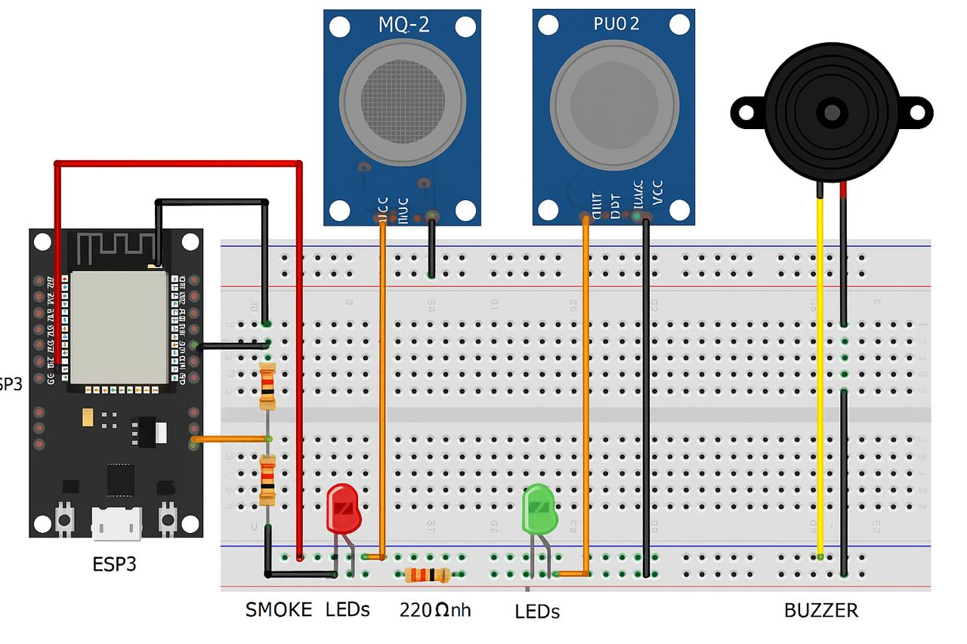
MQ-2 and MQ-135 connected to ADC pins (A0, A1)
LEDs connected to GPIOs via resistors
5.2 Software Design:
Libraries/Tools:
MicroPython via Thonny
urequests (for Blynk HTTP API)
Blynk Cloud and Mobile App
Flowchart/System Logic:
Connect to Wi-Fi
Read sensor values
Turn ON LED if unsafe
Send data to Blynk
Loop
Pseudocode:
connect_to_wifi()
while True:
smoke = read_mq2()
air = read_mq135()
if smoke > threshold or air > threshold:
turn_on_led()
send_to_blynk(smoke, air)
sleep(5)
6. Implementation
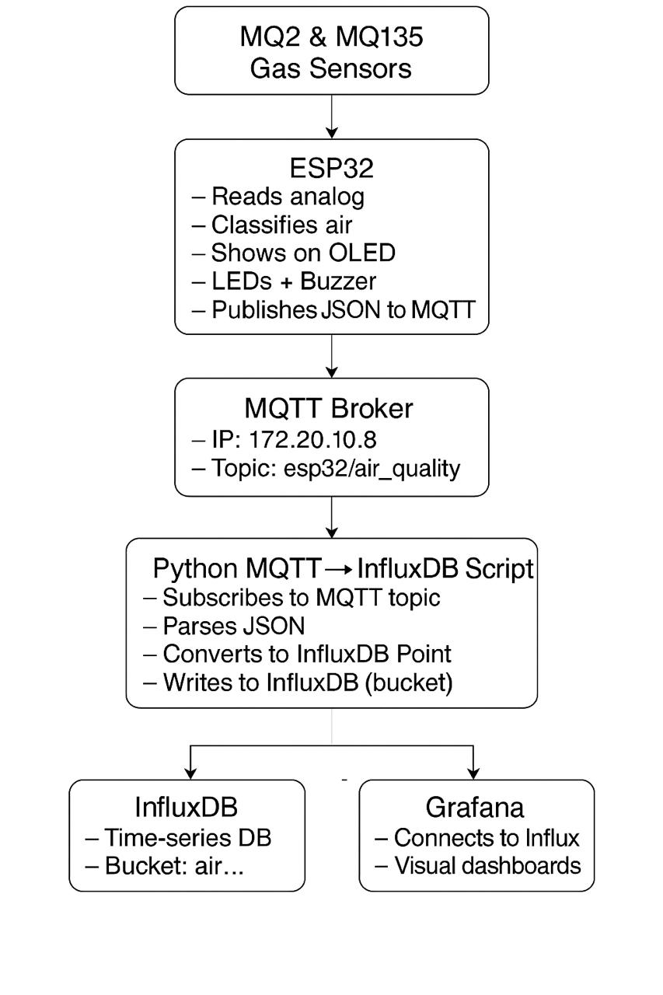
Arduino Code:
// WiFi and MQTT details
const char* ssid = "iPhone 13 Pro";
const char* password = "11223344";
const char* mqtt_server = "172.20.10.8";
const int mqtt_port = 1883;
const char* topic = "esp32/air_quality";

void reconnect_mqtt() {
while (!client.connected()) {
Serial.print("Connecting to MQTT...");
if (client.connect("ESP32_AirQuality")) {
Serial.println("connected");
} else {
Serial.print("failed, rc=");
Serial.print(client.state());
delay(2000);
}

setup_wifi();
client.setServer(mqtt_server, mqtt_port);
}

void loop() {
if (!client.connected()) {
reconnect_mqtt();
}
client.loop();

int mq2Value = analogRead(MQ2_PIN);
int mq135Value = analogRead(MQ135_PIN);

if (mq2Value < 800) {
digitalWrite(GREEN_LED, HIGH);
quality = "GOOD";
} else if (mq2Value < 1800) {
digitalWrite(BLUE_LED, HIGH);
quality = "MODERATE";
} else {
digitalWrite(RED_LED, HIGH);
ledcWrite(buzzerChannel, 128); // Half duty (50%)
quality = "BAD";
}

// MQTT Publish
char payload[150];
snprintf(payload, sizeof(payload),
"{\"mq2\": %d, \"mq135\": %d, \"air_quality\": \"%s\"}",
mq2Value, mq135Value, quality.c_str());
client.publish(topic, payload);
Serial.print("Published: ");
Serial.println(payload);
delay(5000);

Python Script:
# MQTT broker config
broker = '172.20.10.8' # HiveMQ IP
port = 1883
topic = "esp32/air_quality"
client_id = 'mqtt_influx_bridge'

# InfluxDB config
influx_url = "http://localhost:8086"
token = "R5pxqAZrrxiCgsCexGALmwG2PeVaGyqNsMpPAfSy89ufz6z8QuvZCKvz3qlHKaGGILdxkqvf17FkIIlvY9hetw=="
org = "ntu"
bucket = "air_quality_monitor"
def connect_mqtt():
def on_connect(client, userdata, flags, rc):
if rc == 0:
print("Connected to MQTT Broker!")
else:
print(f"Failed to connect, return code {rc}")

client = mqtt_client.Client(client_id=client_id)
client.on_connect = on_connect
client.connect(broker, port)
return client

# Write to InfluxDB
write_api.write(bucket=bucket, org=org, record=point)
print("Written to InfluxDB")
except Exception as e:
print(f"Error processing message: {e}")

def run():
client = connect_mqtt()
client.subscribe(topic)
client.on_message = on_message
client.loop_forever()

Challenges:
Sensor calibration was tricky
urequests sometimes failed due to weak Wi-Fi
Debouncing LED flickers
ESP32 faces challenges in sensor accuracy, data handling, and integrating with other systems
5v Power supply to sensors was tricky

7. Results & Discussion
Outputs:
Sensor readings in serial monitor
Data updates in Blynk app (Gauge, Label widgets)
Performance:
Real-time response ~1s delay
Blynk update stable under 2.4GHz Wi-Fi
MQ sensors show reliable trend changes
Comparison:
Smoke alerts matched real ignition sources
AQI levels increased with lighter spray/smoke test
8. Testing & Validation / Limitations
Test Cases:
Test with candle smoke: LED turns on, Blynk updates
Test with air spray: AQI spike observed
Disconnect Wi-Fi: ESP fails to send, handles exception
Limitations:
No GSM/Offline support
Blynk free plan has data rate limits
Sensors need calibration for real AQI
9. Conclusion & Future Work
Key Takeaways:
Low-cost, real-time detection of air and smoke
Simple Blynk-based dashboard for remote access
MicroPython is suitable for rapid IoT development
Future Improvements:
Add SMS alert
Integrate temperature/humidity sensors
Use AI/ML for pattern detection (fire prediction)
10. References
MQ-2 Datasheet
MQ-135 Info
https://www.youtube.com/watch?v=4cv-6hddJdY
https://www.youtube.com/watch?v=kJ0vG7ZFZ5I

ESP32 MicroPython Guide
https://docs.blynk.io/en/blynk.cloud/blynk-cloud-api
11. Links:
GitHUB Link:
https://github.com/Cyberpunk131/IOT_Lab_work.git
Google Drive Link:
https://drive.google.com/drive/folders/1A54TaqGEvEFDTxvwQCCW43FCw4xULoCz

